Junior Tennis
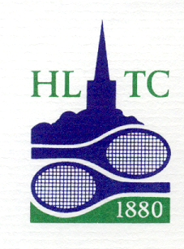

Experienced and enthusiastic LTA licensed coaches who specialise in children’s tennis. Rackets available for lessons

We treat all children as individuals and aim to help each child to be the best they can be using a very positive approach. We hope to develop a love of tennis that will stay with your child for life giving them real confidence and a true sense of achievement for a healthy mind and body.

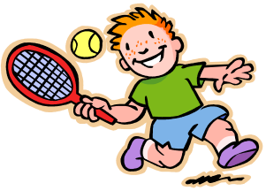

Call Elaina 07789 961142
elainashaina@hotmail.co.uk

Welfare Officer/safeguarding
Nitin Munglani
Membership Kate Close

Saturday’s 2026

Please join our WhatsApp group for up to date, weekly information

Beginners Red Tennis
9.30 - 10.30
4 - 8 years of age
This is the first stage of mini tennis. The emphasis is on developing movement, coordination, ball skills and basic technique.

Advanced Red Tennis
9.00 am - 10.30 am
For those that can rally, we aim to develop consistency, more advanced technique including serving and developing their match play

Mini Orange Tennis
9.00 am - 10.30 am
7 - 11 years of age depending on ability
This stage introduces children to playing on a three quarter sizes court with a ball that bounces at an appropriate height.

Green Tennis
10.30 am – 12.00 pm
9 - 14 years of age depending on ability.
Played on a full size court and may be played with a ball that is slightly softer and lighter than a tennis ball, promoting longer rallies and more enjoyable games

Teen Tennis. All abilities
12.00 – 1.30
Played on a full size court, (some book and play places available),cover all aspects of tennis right from the basics to competitive play

Booking form 2026

Name___________________________
Address_________________________________________________________
Emergency_contact_number_______________________________________
Age _ ___DOB__________
Any health conditions or allergies to note .
Email ___________________________

Please refer to the 'Child Safety-Notes for Parents and Children' on the HLTC website_

For further information please contact
Elaina on 07789 961142
e-mail elainashaina@hotmail.co.uk.

Beginners Red / Advanced Red
Orange / Green (please circle)
Are you a club member Yes/No

1 hour
Members £10, Non members £12

90 Minutes
Members £ 15, Non members £17

Cash or BACS Elaina Forland A/C 57079685 Sort code 09 01 36 using child’s name for reference
Please bring a drink and wear appropriate clothing
We play in most weather, except heavy rain, snow, heavy frost or lightning.

Harrow Lawn Tennis Club
Garlands Lane Off Peterborough Road
Harrow on the Hill HA1 3EA/3GF

